: AUSTRAILAN POLITICAL SPIN

AUSTRALIAN WAY
No matter what side of the AISLE you're on, THIS is FUNNY and VERY telling! It just all depends on how you look at same things.
Judy Rudd an amateur genealogy researcher in southern Queensland ’s, was doing some personal work on her own family tree. She discovered that Prime Minister Kevin Rudd great-great uncle, Remus Rudd, was hanged for horse stealing and train robbery in Melbourne in 1889. Both Judy and Kevin Rudd share this common ancestor.
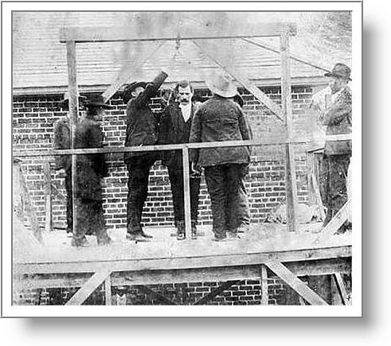
The only known photograph of Remus shows him standing on the gallows at the Melbourne Gaol: On the back of the picture Judy obtained during her research is this inscription: 'Remus Rudd horse thief, sent to Melbourne Gaol 1885, escaped 1887, robbed the Melbourne-Geelong train six times. Caught by Victoria Police Force, convicted and hanged in 1889.'
So Judy recently e-mailed Prime Minister Rudd for information about their great-great uncle. Remus Rudd:
Believe it or not, Kevin Rudd's staff sent back the following biographical sketch for her genealogy research:
"Remus Rudd was famous in Victoria during the mid to late 1800s . His business empire grew to include acquisition of valuable equestrian assets and intimate dealings with the Melbourne-Geelong Railroad.
Beginning in 1883, he devoted several years of his life to government service, finally taking leave to resume his dealings with the railroad.
In 1887, he was a key player in a vital investigation run by the Victoria Police Force. In 1889, Remus passed away during an important civic function held in his honour when the platform upon which he was standing collapsed."
NOW That’s how it's done, Folks!
That's real POLITICAL SPIN.

