[Enter Post Title Here]

Whatever will you do when this will happen??

***AMAZING TECHNOLOGY FROM JAPAN***  
 **You will not be able to know what is ahead** **until you have seen** **it least 4 pictures and read the explanation of what they are, our** **future is here, incredible!!**

**What an age we live in.**   
  
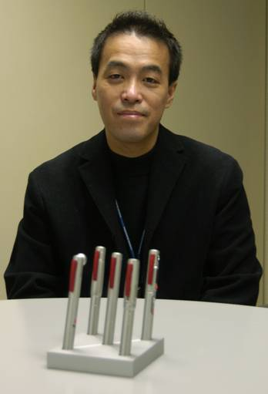  
  
Look closely and guess what they could be...

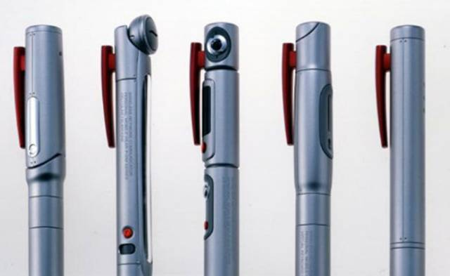  
  
Are they pens with cameras

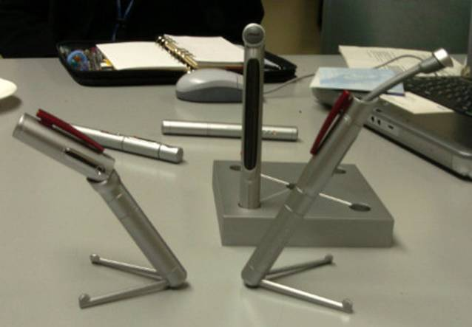  
  
Any wild guesses? No clue yet?   
Ladies and gentlemen.... congratulations!   
You've just looked into the future...   
yep that's right!   
You've just seen something   
that will replace your PC in the near future.

Here is how it works:   
  
  
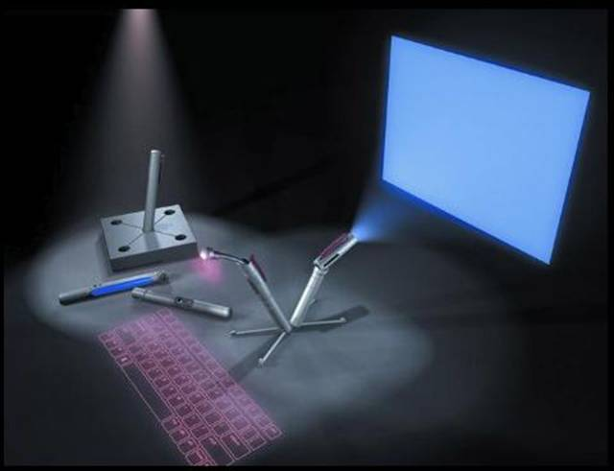  
  
In the revolution of miniature computers, scientists have made great developments with blue tooth technology...

This is the forthcoming computers you can carry within your pockets .   
  
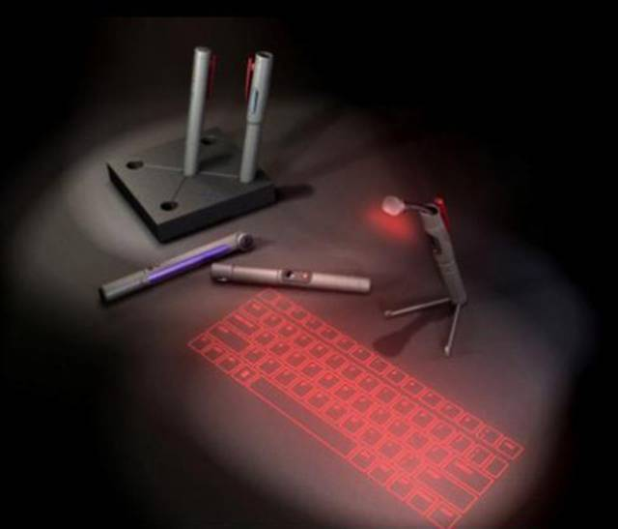  
  
This 'pen sort of instrument' produces both the monitor as well as the keyboard on any flat surfaces from where you can carry out functions you would normally do on your desktop computer.   
  
  
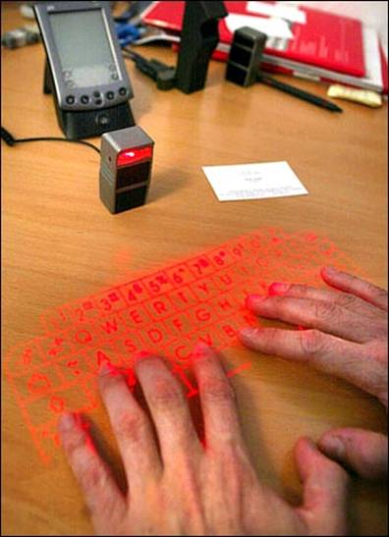  
  
  
  
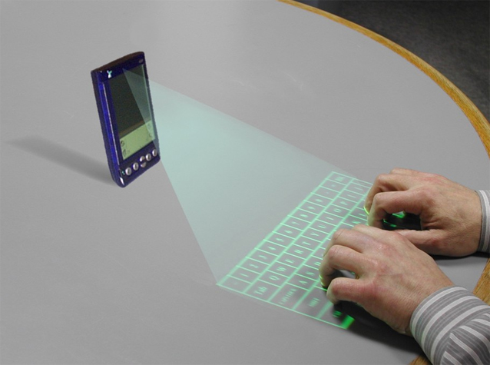  
  
Can anyone say, 'Good-bye laptops!   
  
Looks like our computers are out of date... again!!!