English Welfare at it’s best.

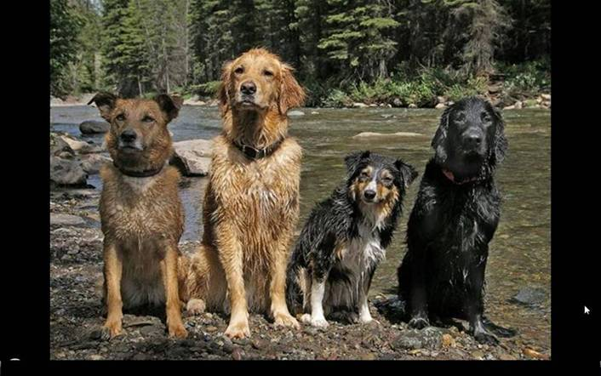   
   
This morning I went to the BC Government office to sign my dogs up for welfare.  At first the lady said,   
"Dogs are not eligible to draw welfare." So I explained to her that my dogs   
are mixed in color, unemployed, lazy, can't speak English and have no frigging   
clue who their Dads are.  They expect me to feed them, provide them with   
housing and medical care. So she looked in her policy book to see what it takes   
to qualify. My dogs get their first cheques next Friday.   
  
Damn, this is a great country.